GIT

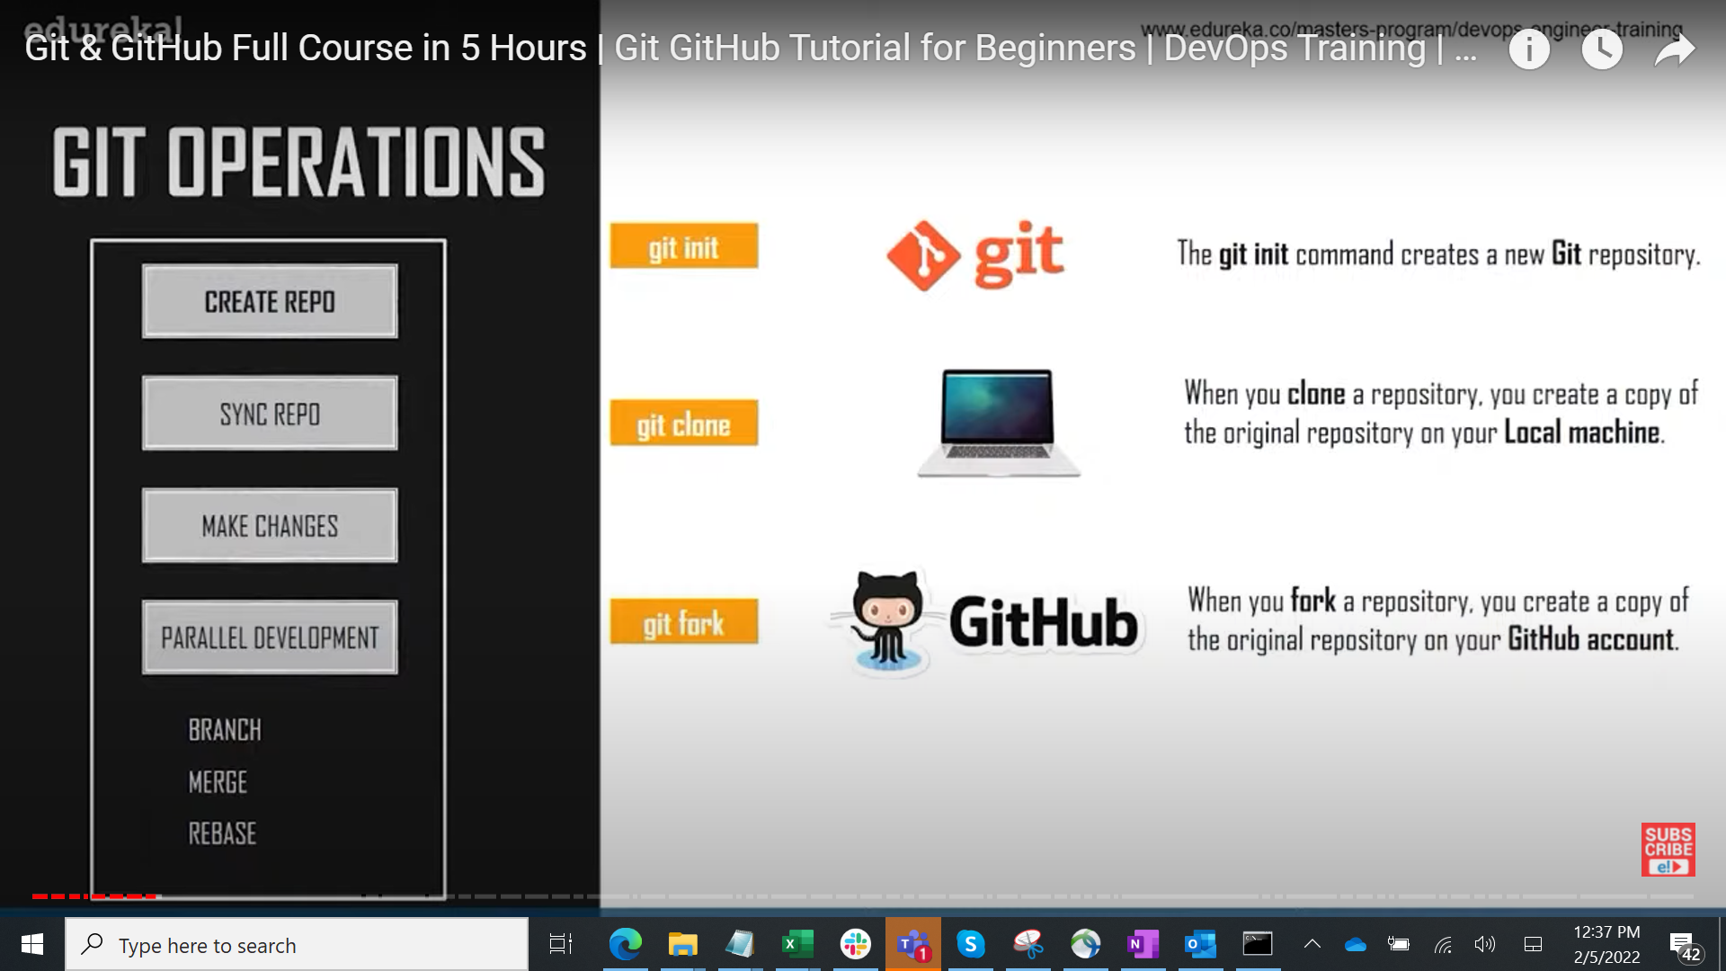

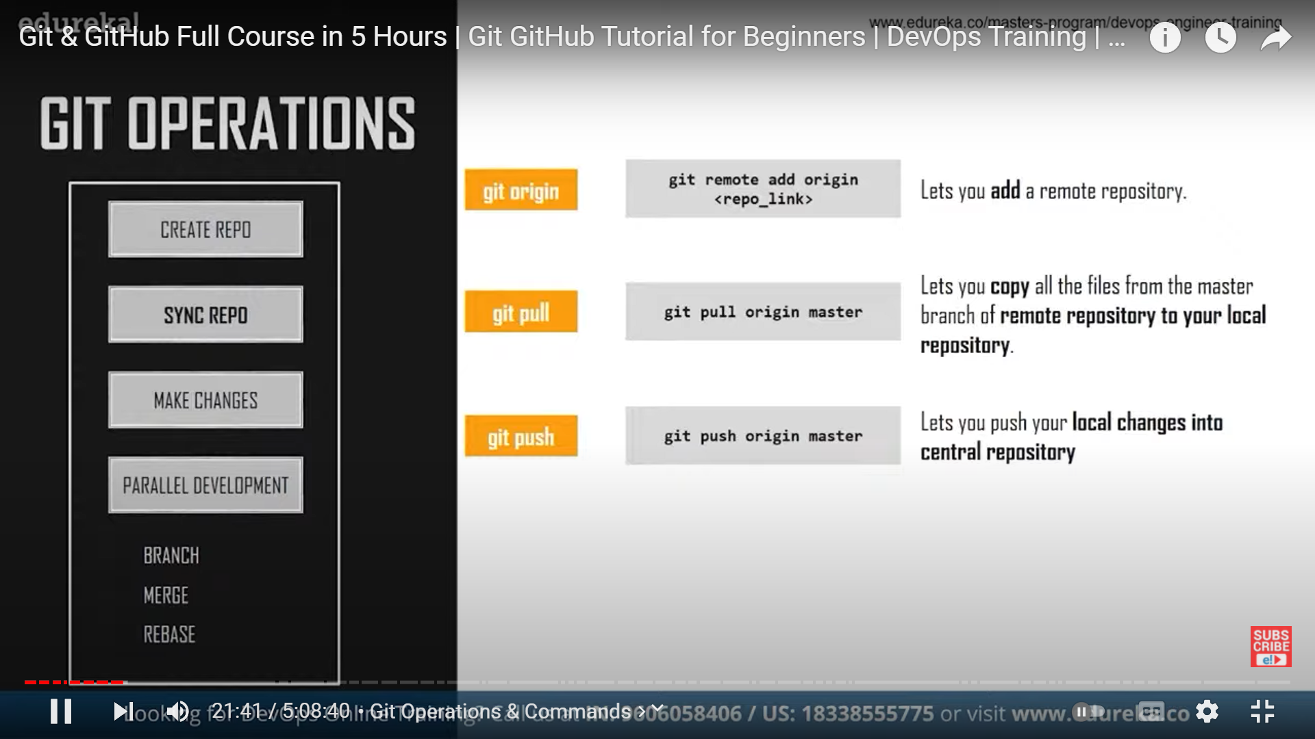

If you want to create a repo on local machine, use git init command, later u can link it to remote repo using git add origin “githubURL” command

If you create a repo on github(remote repo), the create it via GUI and then u can clone it to your local repo
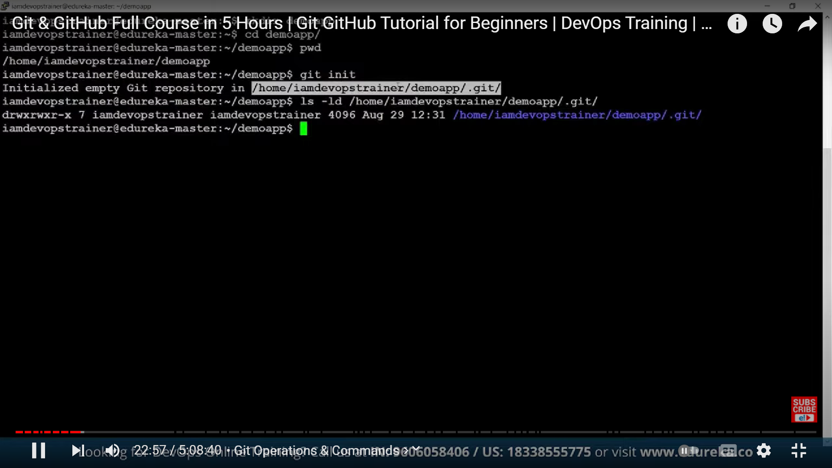

When u use 2 or more local repo,, u will set username and email for each local repo
This helps us track changes between users

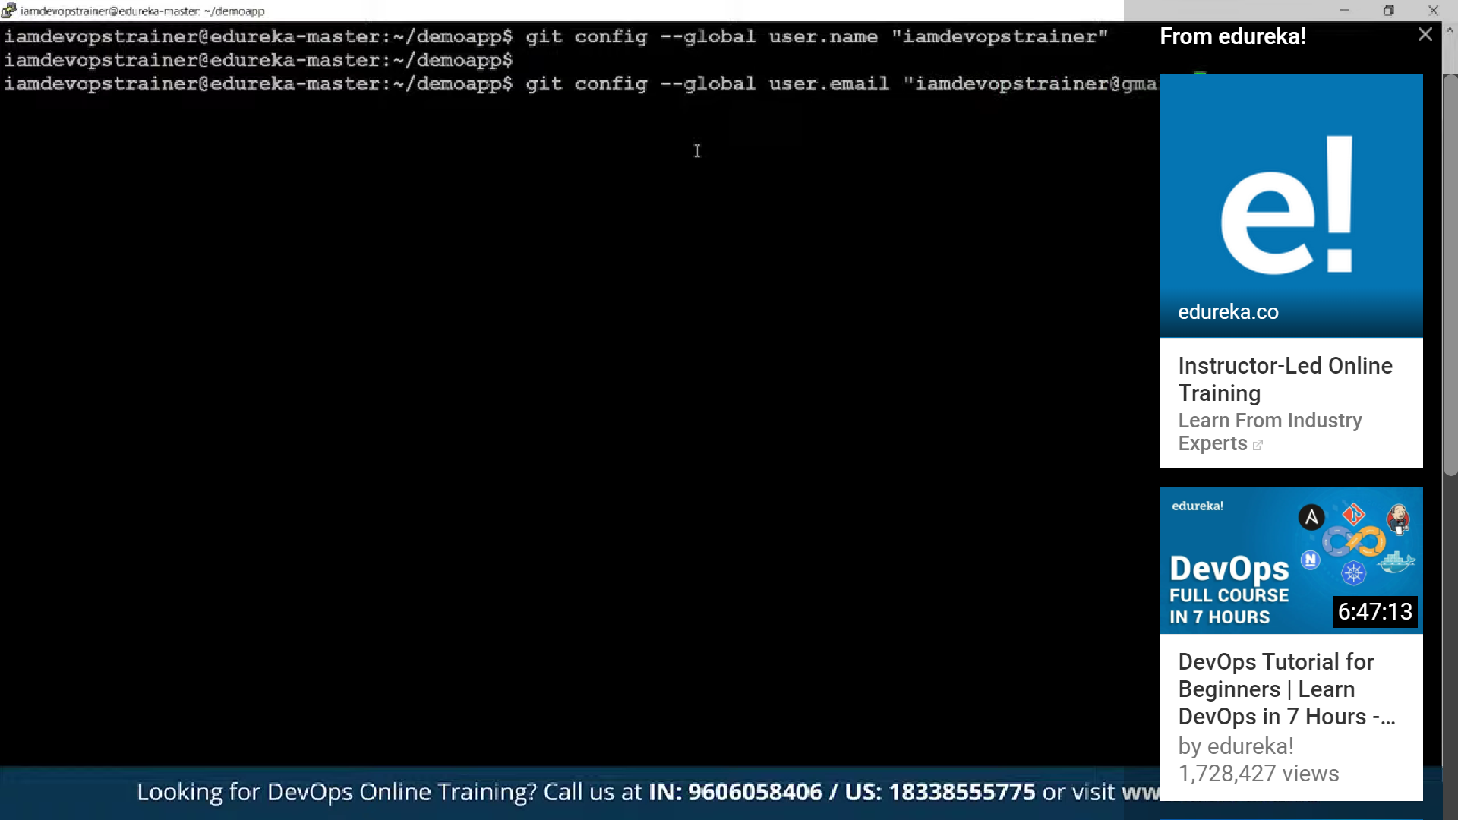

“Git status” to check the status of any untracked files
When using git status on a new file it will show “untracked file”, when using on modified file that already existed, it will show as modified & changes not staged for commit.
Then u can use “git add” to add the modified file. After adding if u run get status the modified will show in green and show “changes to be committed”
Or “git checkout” to discard changes
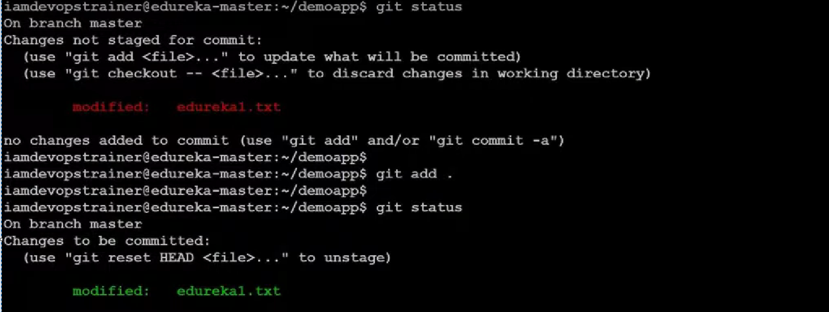

“git add “ to add untracked files to local repo (which will then be ready to be committed)
“git commit -m ‘some message’ ” to commit the changes to local repo
“Git log “ to track the changes made
U can also use “git log –oneline”
With git log command u can get the commit ID

If u use “git show commitID” it will show the modifications done in that specific commit.

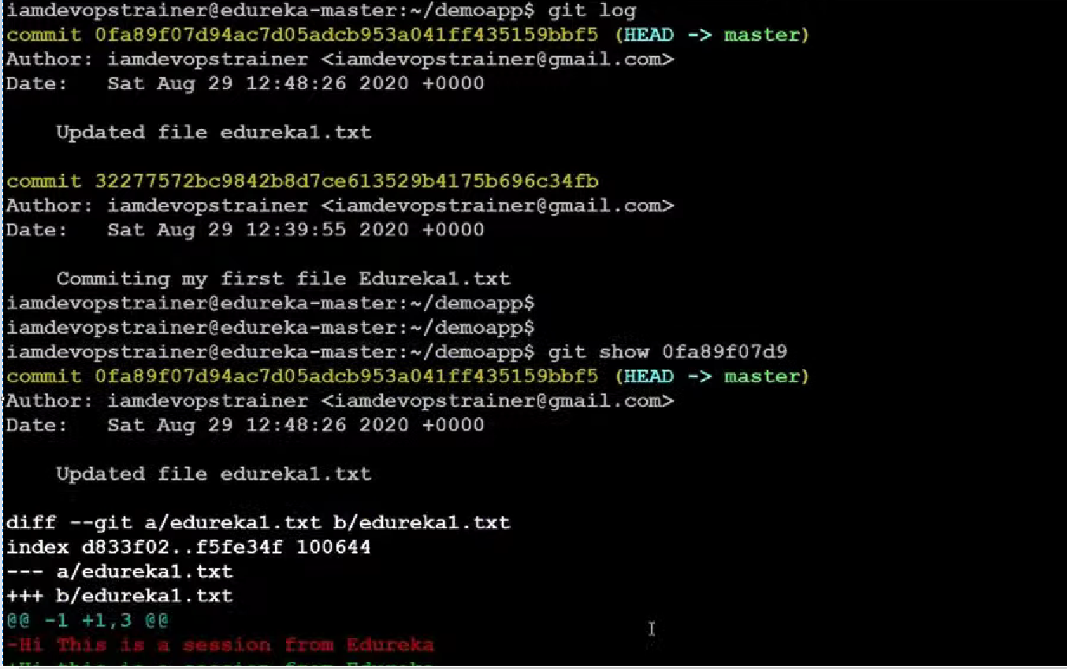

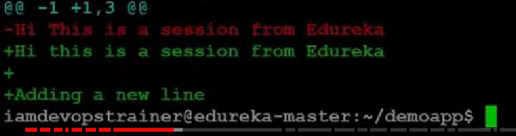

Git ls-files to show all tracked files

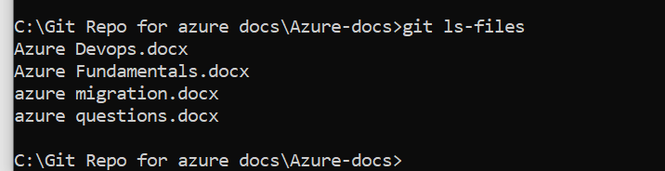
If u want to add this local repo to remote repo in git
Use “git remote add origin https://Princesolomon777/Azure-docs: Azure docs (github.com) “

Git remote -v prints the repo location

“Git push origin master “ to push the changes where origin refers to alias and master is the name of the branch

git push will work

BRANCHING
Git wont create a snapshot of actual files when u create branches, rather it just points to a old state
To list all branches
Git branch
To show current connected branch
When u run git branch – ull see the current branch highlighted with*
Or u can run git status, it will also show current branch
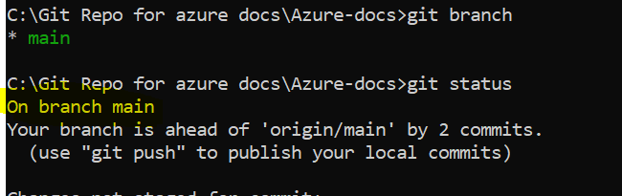

To create new branch
Git branch <BRANCH NAME>
When u create a new branch from existing one, it copies all the commit IDs to the new branch

To switch to another branch
Git checkout BRANCHNAME
USING MERGE COMMAND
To merge changes from one branch to another branch
Checkout to the branch where u need to have the changes
Run “git merge DESTINATIONBRANCHNAME”
It will then merge changes from that destination branch

USING REBASE COMMAND
To merge changes from one branch to another branch
Checkout to the branch where u have made the changes
Run “git merge SOURCEBRANCHNAME” to which u want to merge
It will then merge changes to that destination branch

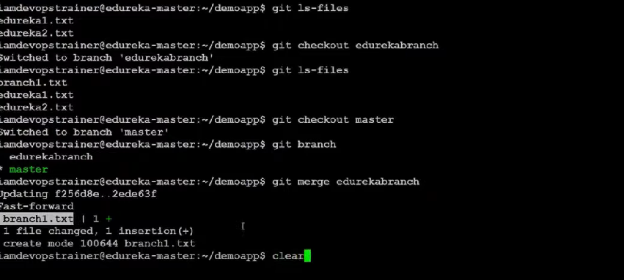

Git Archive
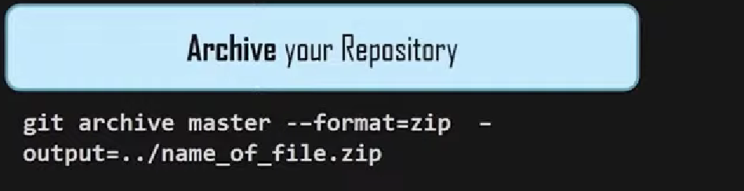

BUNDLE

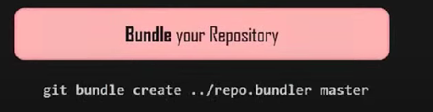
GIT STASH

Save all uncommited changes to a temp location

